TRYHACKME LAB WRITEUP 03 / 04

Intro to Log Analysis
  - Training-room summary and evidence-aware reflection

Training reference
https://tryhackme.com/room/introtologanalysis

Learning objectives
- Search logs by timestamp, hostname, IP, user or event message.
- Correlate several related events instead of treating one hit as proof.
- Preserve a record of the investigated filters and findings.

Concepts reviewed
Filtering and comparing security records separates expected activity from suspicious patterns.

Approach and SOC interpretation
- Identify which log or packet field directly supports a claim.
- Filter by event time and asset before drawing conclusions.
- Explain to a SOC analyst why the result could matter and how it may be validated.

Evidence and completion status
Learner reported completing this room; the supplied ZIP contains the room screenshot. Screenshot evidence is attached below.
The room screenshot was supplied; no downloadable raw log or task-by-task screenshots were in the ZIP.
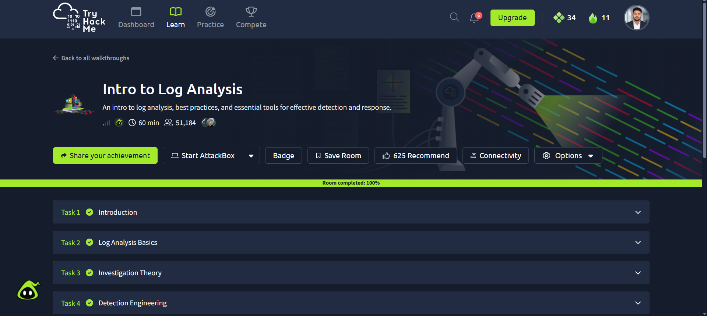
Evidence: source screenshot provided for Intro to Log Analysis

Reflection / relation to the lab
This room connects to the Windows Sysmon, Linux auditd and Snort exercises documented in the Week 3 practical report. Specific room questions, answers and typed commands are intentionally not claimed without source evidence.

